Binary Logic

NOT Gate

Use the space below to draw what an NOT gate looks like in a diagram, remember to give it input and output lines.

Now can you work through the logic of the system to produce the truth table for an NOT gate

|  |  |
| --- | --- |
| Input | Output |
|  |  |
|  |  |

AND Gate

Use the space below to draw what an AND gate looks like in a diagram, remember to give it input and output lines.

Now can you work through the logic of the system to produce the truth table for an AND gate

|  |  |  |
| --- | --- | --- |
| Input A | Input B | Output |
|  |  |  |
|  |  |  |
|  |  |  |
|  |  |  |

OR Gate

Use the space below to draw what an OR gate looks like in a diagram, remember to give it input and output lines.

Now can you work through the logic of the system to produce the truth table for an OR gate

|  |  |  |
| --- | --- | --- |
| Input A | Input B | Output |
|  |  |  |
|  |  |  |
|  |  |  |
|  |  |  |

Practice Exam Question 1

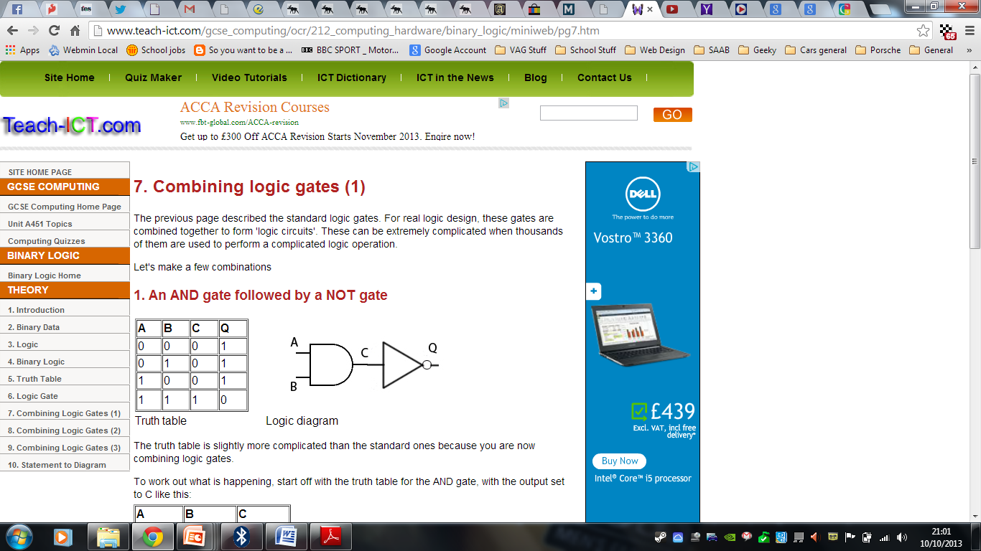

Use the space below to draw your own truth table for the logic gates above.

Practice Exam Question 2

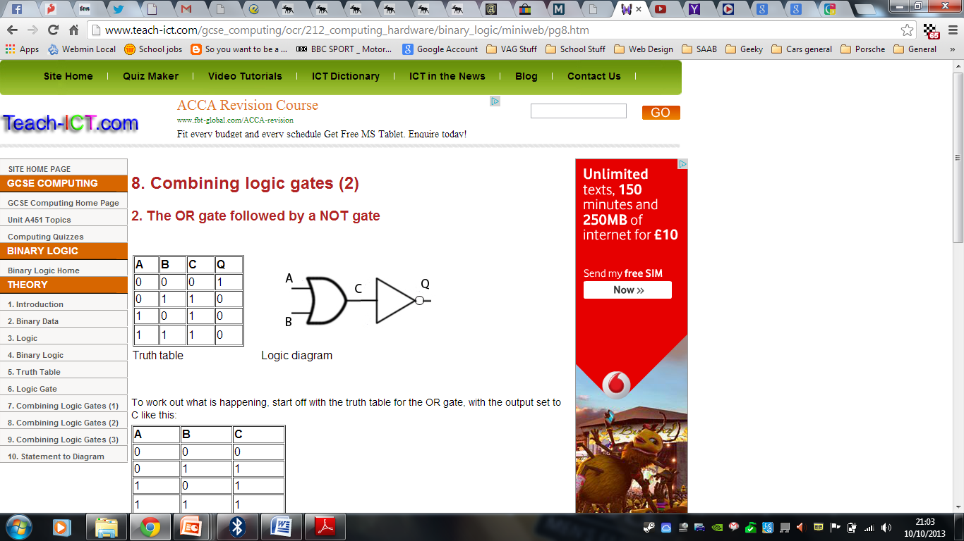

Use the space below to draw your own truth table for the logic gates above.

Practice Exam Question 3

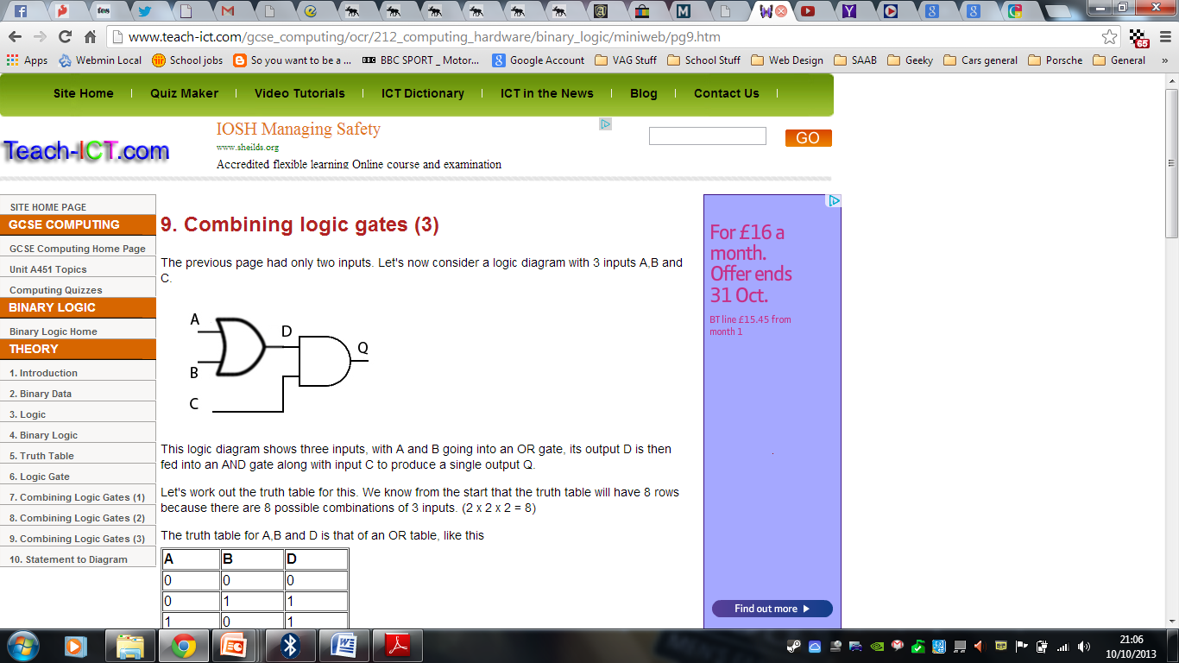

Use the space below to draw your own truth table for the logic gates above.